# Introduction

Inductive power transfer (IPT) has become more popular in recent years. It is used in range area from low power applications to high power applications. Cordless design and spatial flexibility of IPTs led them to be used in some applications such as portable chargers, biomedical implements, etc. Also, providing electrical safety and galvanic isolation make them the future of the electric car chargers and energy harvesting systems, etc.

Besides the advantages, the IPT system also allows the multiple transmitters (Tx) and receivers (Rx). Multiple Tx-Rx systems are investigated and analyzed for various applications in the literature. Multiple Tx coils are implemented to obtain higher power ratings. Thus, voltage or current ratings of the system can be increased without changing the ratings of the semiconductors. Moreover, multiple Tx can be used to avoid misalignment. A misalignment can decrease the output power drastically and a misalignment tolerant system can be designed by using more than one Tx coupled with a Rx. Another use of multi Tx is to meet requirements of the multiple loads such as electric car charger and consumer electronics. On the other hand, coupling between Tx coils raise an issue and it is unavoidable in some application due to insufficient space. In the literature, the effect of coupling between Tx coils on resonance frequency, output power and efficiency are analyzed and they bring some solutions to avoid the effects.

Also, multiple Rx coils are implemented for the similar aims of multiple Tx. For example, multiple Rx coils increase the fault tolerance for some IPT topologies since Tx side draws short circuit current if there is no load on the receiver (open circuit Rx coils or zero coupling coefficient between Tx and Rx). Moreover, multiple Rx can be used to obtain higher power ratings. For this usage, either the load of each Rx may be separate or unified. For unified load conditions, Rx’s can be connected series or parallel to each other’s.

In literature, parallel-connected Rx’s are analyzed and sharing power between Rx’s, or can be named as load balancing, raises a problem. In the literature, either the problem is solved by replacing passive rectifiers with active rectifiers and implementing control algorithm or by applying post-regulation by a DC-DC converter (Buck, Boost, Buck-Boost, etc.). However, the solutions are hard to implement and cause excess components and cost.

In this paper, we propose that we can share the power between Rx’s equally with by adjusting the coupling between Rx coils. Although the coupling between Rx coils affect the output power, efficiency and frequency as in the Tx coils, we can design the system considering the couplings and use the couplings for load balancing.

In first section, ….

# Rectifier effect and load distribution

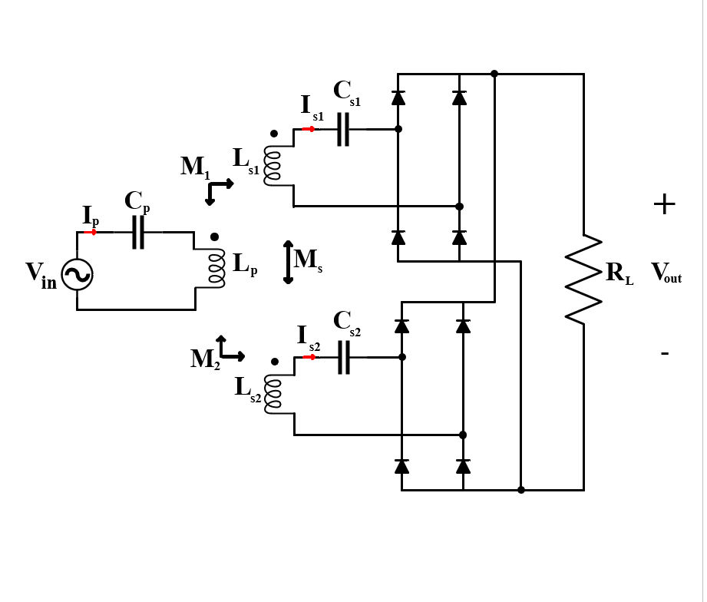

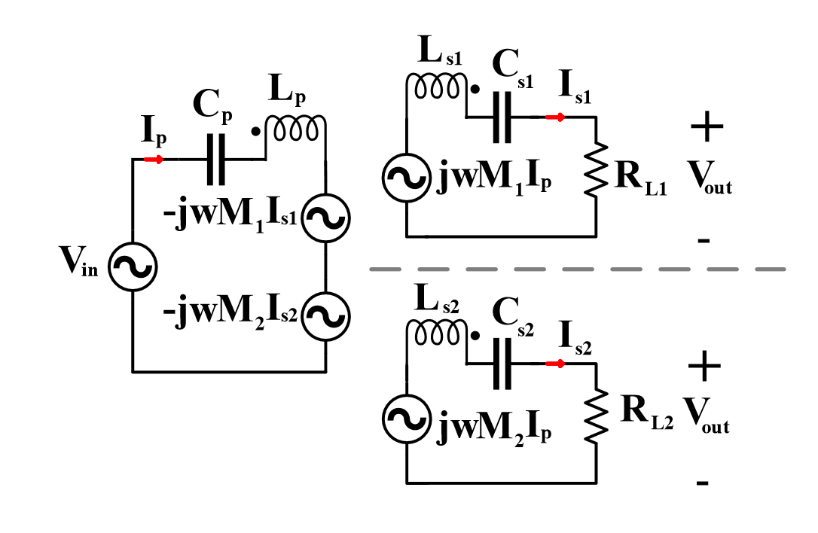

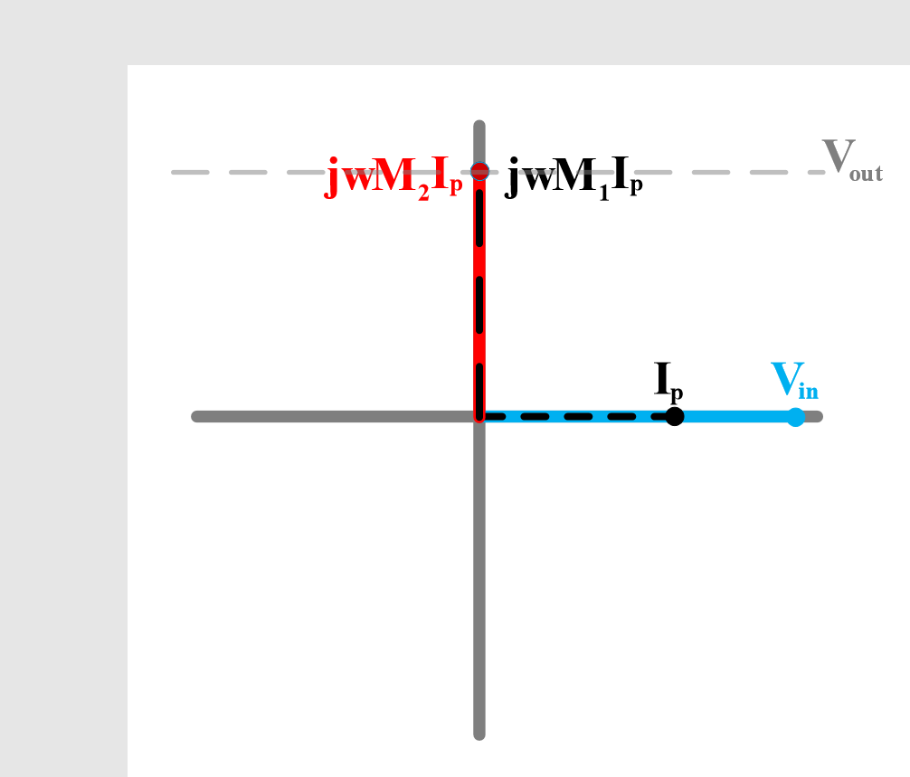 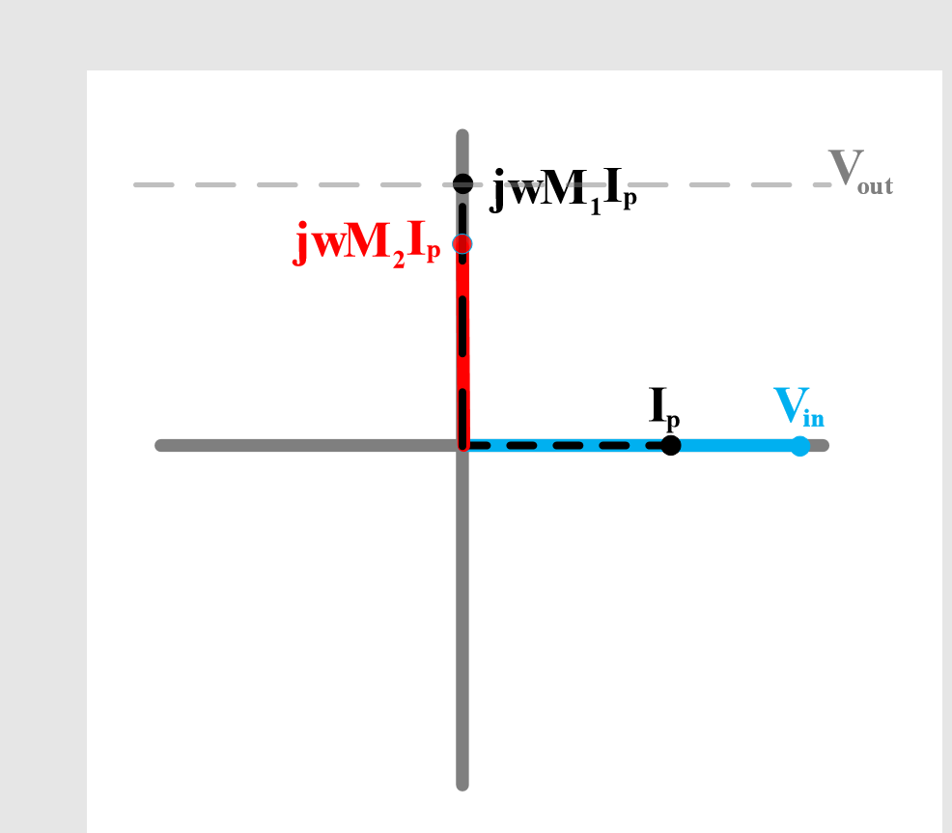

In the section 1 and 2, we find the required circuit parameters to operate desired output voltage without bifurcation by making three assumptions that the coupling coefficient between Tx and Rx's are same, the coupling coefficient between Rx's zero and load is shared to Rx's in equal. However, the assumptions are insufficient for parallel connected Rx’s with common DC Bus as shown in fig. \ref{fig:Rectifier-1tx-2rx}. Although the connections keep each Rx output voltage same, it does not mean to share the power or load in equal. Actually, the distribution of the load is destroyed when any differences of the coupling coefficient between Tx and Rx's. In this section, the effect of the coupling coefficient between Tx and Rx's on the distribution of the load current are analyzed without the coupling between Rx coils.

The analyses are done by using phasor domain. The equivalent phasor domain circuit is shown fig. \ref{fig:1tx-2rx-decoupled-phasor}

If the system operates at resonance frequency(150kHz), we know that the impedance of the series inductor and capacitor behaves like short circuit without parasitic components. Then, we can say that induced voltages at Rx’s can be conceivable as output voltage as shown eq. \ref{eq:Vout1} and eq. \ref{eq:Vout2}.

This is also valid for Tx and the equality is shown eq.\ref{eq:Vin}

Firstly, we analysis the situation of the equal mutual inductance between Tx and Rx’s. The phasor diagram of the input and induced voltages at Rx’s are shown fig. \ref{fig:Equal_coupling_vector}. In this situation, induced voltage of both Rx coils are equal to output voltage. Thus, the designed circuit operates as desired and Rx’s share the power in equal.

Secondly, we analyze the situation of inequal mutual inductance between Tx and Rx’s. In this situation, the induced voltage of the Rx coils with lesser coupling coefficient is smaller than induced voltage of the other Rx coil as shown at fig. \ref{fig:Inequal_coupling_vector}. Thus, the power is transferred by only one Rx since the diode rectifier of the Rx with lesser coupling coefficient blocks the current. Although the power is transferred by only one Rx coil, operation of Tx coils does not change.

Hence, one Rx has to supplies twice the desired current and the system behaves like 1Tx-1Rx. Although the design can be used to make the system no-load fault tolerant, it is not suitable design to increase the power ratings.

(Burada lead lag meselesini de konuşmak lazım aslında)

# Secondary coupling ratio and unbalanced.

We observed that unequal couplings between Tx and Rx’s led unbalanced load distribution between Rx’s in the section 3. Actually, the problem stems from the lack of feedback mechanism. If the passive rectifiers could be placed with active rectifiers, the control algorithm can be applied to balance the current of Rx’s. Also, if the system includes DC-DC converter at each Rx module, the current of the Rx can be regulated and shared in equal. However, we do not have either active rectifier or DC-DC converters in our system. It brings an additional cost and problems of implementation. However, we propose that the coupling between two Rx can be used as feedback mechanism and the current distribution can be adjusted by using the couplings. Besides the couplings does not additional cost and implementation problems, the requirement of shielding of the Rx’s also disappears.

In the section, the effect of the couplings between Rx's on the current distribution are analyzed analytically. First of all, we can update the circuit representation including Rx’s coupling as shown figure X. As can be seen in the figure, induced voltage for each Rx’s is affected by the current of other Rx anymore. Hence, the voltage waveform of each Rx does not lead the 90 degree to the Tx current and the induced voltage of each Rx modules can reach the output voltage with the help of other Rx.

It can be thought as a circular domino. Tx current creates an induced voltage at Rx’s and dominant Rx module creates a current due to the induced voltage. The current of dominant Rx also creates an induced voltage at recessive Rx’s in addition to Tx. The phasor sum of the induced voltages at recessive Rx’s can reach the induced voltage of the dominant Rx. Also,the input current changes due to change on the currents of Rx’s.Thus, the power is transferred by both Rx even if the case of unequal coupling between Tx and Rx’s and . The phasor diagram of input and output voltages are represented as figure X1 X2 X3 for unequal coupling and negative coupling between Rx’s.

In this point, a question of how much the coupling ratio between Rx’s arises. The coupling should provide a sufficient current in the case of unequal couplings. Thus, we should find thee required coupling between Rx’s to provide the sufficient current for maximum difference in the couplings between Tx and Rx’s.

For example, we can say that maximum difference of the coupling between Tx and Rx’s is 20 percent and we can want also the difference of the current is 20 percent. In this case, we should answer the question of how much do we need coupling between Rx’s. The answer is found by an analytical calculation in below step by step.

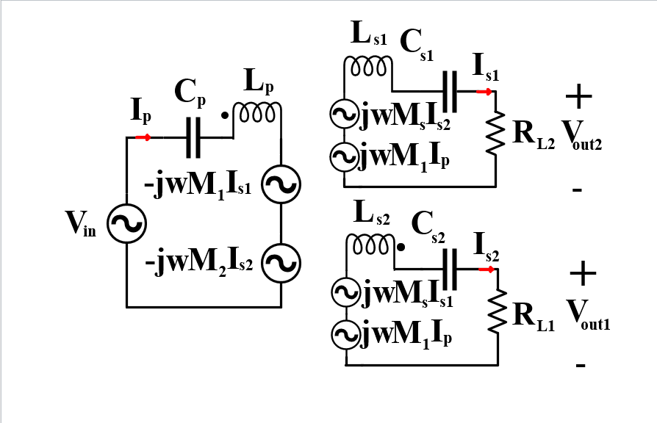

We have three equation (Eq. \ref{},Eq. \ref{},Eq. \ref{} ) which define the input and output voltages as phasors at 1Tx-2Rx designed resonance frequency ( 150 kHz )

$$V_{in}\sin\left(wt\right)=-(wM_{1}I_{s1}\cos\left(wt-α\right)+wM_{2}I_{s2}cos⁡(wt-β))$$

$$wM_{1}I_{p}\cos\left(wt-θ\right)+wM_{s}I_{s2}\cos\left(wt-β\right)=V_{out}sin⁡(w_{t}-α)$$

$$wM_{2}I_{p}\cos\left(wt-θ\right)+wM_{s}I_{s1}\cos\left(wt-α\right)=V_{out}sin⁡(w_{t}-β)$$

Secondly, we can know that the magnitude of the output voltages of Rx’s are equal but the phase of them depends on each Rx’s current. Then, we can define the input and output parameters as in table X.

|  |
| --- |
| Parameters |
| $$V_{in}sin⁡(wt)$$ |
| $$I_{p}sin⁡(wt-θ)$$ |
| $$I_{s1}sin⁡(wt-α)$$ |
| $$I_{s2}sin⁡(wt-β)$$ |
| $$V_{out1}sin⁡(wt-α)$$ |
| $$V_{out2}sin⁡(wt-β)$$ |

Thirdly,

$$V_{in}\sin\left(wt\right)=-(wM_{1}I_{s1}\cos\left(wt-α\right)+wM_{2}I_{s2}cos⁡(wt-β))$$

$$wM_{1}I_{p}\cos\left(wt-θ\right)+wM_{s}I_{s2}\cos\left(wt-β\right)=V_{out}sin⁡(w_{t}-α)$$

$$wM_{2}I_{p}\cos\left(wt-θ\right)+wM_{s}I_{s1}\cos\left(wt-α\right)=V_{out}sin⁡(w_{t}-β)$$

Fourthly, we can apply the trigonometric transformation of the difference of the angles.

6.

7. Them we determine the parameters of the system. 1Tx-2Rx system design results are used as input parameters. There are some unknown parameters shown in table X.

|  |
| --- |
| Input Parameters |
| $ω$ (rad) |
| $L_{p}$ (H) |
| $L_{s}$ (H) |
| $M_{1}$ (H) |
| $M_{2}$ (H) |
|  |
|  |
|  |
|  |

|  |
| --- |
| Output Parameters |
| $V_{out}(V_{peak})$ |
| $I_{p}.cos⁡(θ)\left(A_{peak}\right)$ |
| $α$ |
| $β$ |
| $I_{p}\left(A_{peak}\right)$ |
| $$θ$$ |
| $M_{s}$ (H) |
| $$Q_{s1}$$ |
| $$Q_{s2}$$ |

8.

The output voltage is calculated by desired Rx currents and load resistances. Also, the the projection of input current on input voltages is calculated by taking efficiency as 100 percent.

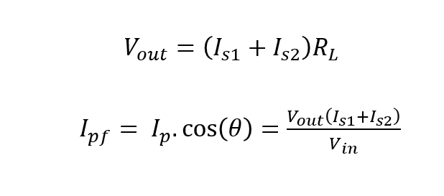

9. For negative coupling between the Rx, we know that dominant Rx current lead the input voltage in the range of 0 and 90. Also, we know that recessive Rx current lead the input voltage in the range of 90 and 180. We can find the angles by using equation (Tx side).

10. We can find the required M_s by using the equation (1 tane RX) or equation (diğer Rx pair). In this equation, \theta and M_s are unknown parameters. We can reshape the equation in linear form as changing the paremeter as tan(theta) and M_s.

11. Also, in our circuit quality factor changes due to the effect. We can update the quality factor as equation (bla bla)

SON DEVRE REZONANS VE GAIN,BIFURCATIONINCELENMESI

In this section, the effects of coupling between Rx’s on resonance frequency and bifurcation phenomena are investigated. Although the coupling between Rx’s can be used to balance the Rx’s current, it led the system characteristic such as input impedance and input current etc. change. To analyzed the changes, we firstly create the impedance matrices as shown equation X.

|  |  |  |  |  |  |  |
| --- | --- | --- | --- | --- | --- | --- |
| $$Z_{p1}$$ | $$-jωM_{1}$$ | $$-jωM_{2}$$ |  | $$I_{p}$$ |  | $$V_{in}$$ |
| $$jωM_{1}$$ | $${-Z}_{s1}$$ | $$jωM_{s}$$ |  | $$I_{s1}$$ | = | 0 |
| $$jωM_{2}$$ | $$jωM_{s}$$ | - $Z_{s2}$ |  | $$I_{s2 }$$ |  | 0 |

In impedance matrix, the parameters Zp,Zs1,Zs2,M1,M2 are found in the section 3 and the parameters Ms is found in section 4. Zp includes the resonance capacitor and Tx inductor where the resonance frequency is adjusted 150kHz. Zs1 and Zs2 include the resonance capacitor and Rx inductor and Load resistance.

Then, we can represent the Zp, Zs1 and Zs2 as inductances,operation frequency and 150kHz (resonance freqeuncy). If \deltaW is defined as w^2-w_r^/w , Zp1,Zs1,Zs2 can be represented as equation 1 2 3. To derive the Tx and Rx’s current, we can take the inverse of impedance matrices.

$$I=Z^{-1}V$$

The only first column of the inverse of impedance matrices is required to find the Tx current. If we can calculate of the matrix of minor for first row and taking matrix of cofactors, we can find the adjoint matrices by taking transpose of it. After the operation, the adjoint matrices are divided by determinant to obtain inverse of impedance matrix.

|  |  |  |  |  |  |  |
| --- | --- | --- | --- | --- | --- | --- |
| $$\frac{m_{1}}{det⁡(Z)}$$ | $$-$$ | $$-$$ |  | $$V_{in}$$ |  | $$I_{p}$$ |
| $$\frac{{-m}_{2}}{det⁡(Z)}$$ | $$-$$ | $$-$$ |  | $$0$$ | = | $$I_{s1}$$ |
| $$\frac{m_{3}}{det⁡(Z)}$$ | $$-$$ | $$-$$ |  | $$0$$ |  | $$I_{s2 }$$ |

Thus, we obtain the Tx current as shown in equation and input impedance can be calculated by V_in/I_p as shown in equation.

$$Z_{in}=\frac{Z_{p1}Z_{s1}Z_{s2}+ω^{2}M_{s}^{2}Z_{p1}+ω^{2}M_{1}^{2}Z_{s2}+ω^{2}M_{2}^{2}Z_{s1}+2jω^{3}M_{1}M_{2}M_{s}}{Z_{s1}Z_{s2}+ω^{2}M_{s}^{2}}$$

If we find zero phase angle of Zin, we obtain the resonance frequency and investigate the bifurcation phenomena. Firstly, we place the all variables in the equation. We obtain the formula as shown equation X. In this equation, we can abbreviate this by ignoring \deltaW part inside W part. Then we obtain the fourth degree equation as shown equation X. Then the roots of the equation are found by the formula. However, this formulation is only valid for small coupling between -0.3 and 0.3 due to our assumption. In the figure X, parametric sweep of M_s , analytical calculations are shown.